Dock leveler GA Drawing-

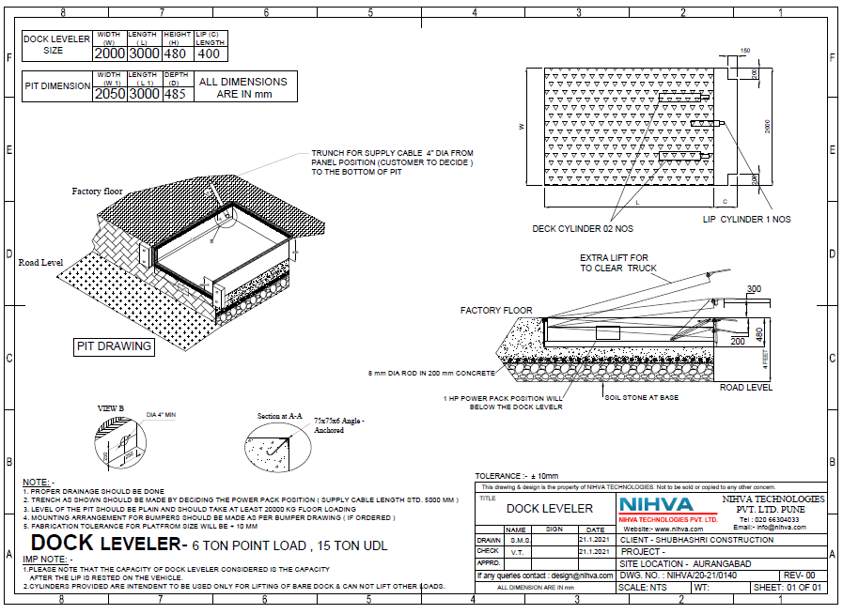

- Technical submittals

Hydraulic Dock leveler : Hot Dip Galvanised
Sr. NO | Description | Specification
1 | Capacity | 6 Ton Point Load ( 15 Ton UDL)
2 | Platform Size | 2000 mm (W) X 3000 mm (L)
3 | Shut Height | 480 mm
4 | Dock Operation Mode | AC Powerpack Hydraulically Operated
5 | Lip Operation mode | Hydraulic
6 | Operation Control | Through Panel by push button.
7 | Loading Platform height from road | 1200 -1300
8 | Travel above & below dock leveler | (+) 300 / (-)250
9 | Lip Size | 2000 X 400
10 | Clear Pit dimensions | 2050(w) X 3000(l) X 480 (h)
11 | Hydraulic Power pack | Standard with Rexroth Gear Pump
12 | Motor rating | 1 HP , Siemens
13 | Safety Valve set pressure | 120 kg/cm²
14 | Volume of hydraulic Oil receiver | 7 Liter (Servo-Grade 68)
15 | Hose | Parker Hoses
16 | No.of Deck Cylinder | 2 Nos.
17 | Lip cylinder | 1 No.
18 | Dock bumper | Pair of Dock bumper of EPDM rubber
19 | Deck Plat thickness | 8mm
20 | Lip Plat thickness | 14mm

